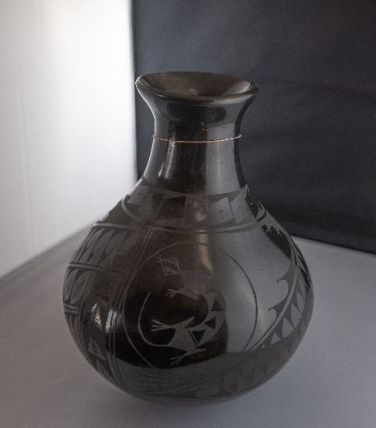
Title: Mata Ortiz Vase
Description/Details: A small handmade coiled vase in the black on black Mata Ortiz style with matte black geometric designs and lizard motifs on polished black ware. Engravings combine pre-Hispanic ancestral symbols with contemporary ones designed by the potter. The designs are hand-painted.
Creator: Maria Chavira, Mexican (signed at the bottom with Mata Ortiz tag)
Date: c. 20th century
Medium: Mata Ortiz pottery (hand painted blackware)
Place of Origin: Mata Ortiz, Chihuahua, Mexico

Cultural Background:
Mata Ortiz style details
The style is named after the present town of the same name located near the archeological site of Paquime, Casas Grandes. Mata Ortiz pottery is often referred to as Casa Grandes pottery or Mimbres pottery.

The Mata Ortiz style was rediscovered by Juan Quezada. In the early 1970s, Quezada found pottery shards from the pre-Columbia cultures of Mimbres and Casas Grandes. The shards from the 13th and 14th centuries inspired him to replicate them. Quezada, with no formal pottery making education or help from experts figured out how to recreate the traditional process.

Spencer MacCallum, an archeologist, discovered the art of Quezada and helped him break the American art market. Quezada’s success in pottery sparked the interest of his town and he began teaching family and friends how to replicate traditional Mimbres pottery. Today, most of Quezada’s family and other households of Mata Ortiz own pottery workshops. Over 600 people from the area are involved in Mata Ortiz pottery. The region is considered an epicenter for the revival of indigenous pottery traditions and throughout the years has gained international acclaim.

Technique and Materials
Mata Ortiz pottery incorporates elements of contemporary and prehistoric design and decoration
from the Casas Grandes and Mimbres civilizations. It incorporates pottery traditions passed down by generations of more than two thousand years of history. Mata Ortiz pottery is done entirely by hand—the shaping, polishing, and painting are all done by hand. The materials come directly from the surrounding area. The clay (gray, yellow, orange, red, and white) comes locally from the valley floor or the foothills of the Sierra Madre Mountains. Paints are made from crushed manganese and grinding other minerals into a fine powder. Brushes from human hair are specially created to paint very fine lines and intricate designs. Each piece is signed (painted or engraved) by the artist either on the inside or at the bottom of the vessel created.

Mata Ortiz pottery fired on the ground with wood rather than in a kiln. It uses low-temperature firing using grass-fed cow manure or split wood. Furthermore, there are two different styles of firing: oxidation or reduction. To achieve the black on black pottery, firing conditions are altered. Pulverized manure is placed beneath the vessel and then covered with a metal box. A clean fire burns on the outside of the metal box while a smoky fire burns inside the metal box, hardening and blackening the vessel. Black on black is considered to have been developed by Lydia Quezada, Juan Quezada’s youngest sister.

There are a wide variety of forms and techniques of Mata Ortiz potter. Ollas and effigies are executed in various clay colors (red, buff, white, cream, black), and embellished with slip painting, carving, marbling, sgraffito, or graphite application. Furthermore, Mexican art historians have divided the styles of pottery into three categories: Quezada, porvernir, and innovador.

The most common and recognized style, Quezada, is characterized by symmetry, refined composition, and curved lines. Some of the well known artista of the Quezada style include: Juan Quezada Celado, Lydia Quezada Celado, Nicolás Quezada Celado, Noé Quezada Olivas, Mauro "Chico" Corona, Damián Escárcega Quezada, Elvira Antillón, Héctor Gallegos Flores, Graciela Martínez Esparza, César Domínguez Alvarado, and Gabriela Almeida Gallegos. The next style, porvenir, is characterized by the zoomorphic and anthropomorphic forms, sgraffito technique, and straight lines. The main artists of the style include: Macario Ortiz Estrada, Nicolás Estrada Ortiz, Eduardo "Chevo" Ortiz, Rubén Lozano Lucer, Eli Navarrete Ortiz, Jaime Quezada, Olga Quezada Hernández, and Humberto Ledezma. The last style, innovador, is characterized by its prevalent Anasazi and Mimbres. Also, potters focus on the painting rather than the form or design of the vessel. Some of the artists practicing this style include: Leonel López Sáenz, Reynaldo Quezada Celado, Manuel "Manolo" Rodríguez Guillén, Roberto Bañuelos, and María de los Ángeles.

Info from https://www.flordebarrogallery.com/juanquezada
Mata Ortiz Pottery https://alltribes.com/mata-ortiz-pottery/
http://rarepotteryinfo.siteprotect.net/protect/MataOrtizMaryChavira.htm

