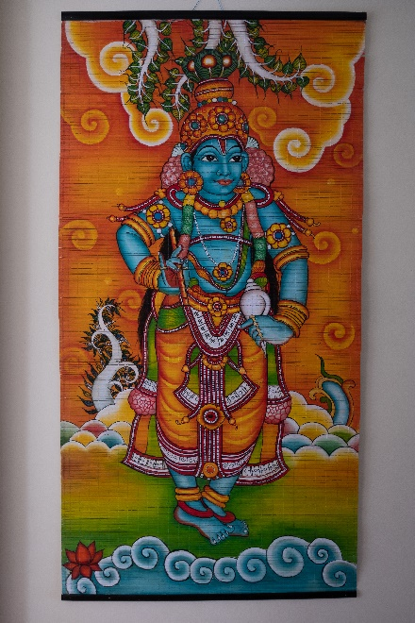
Title: Lord Krishna
Description/Details: A vibrant and colorful painting of Hindu deity Krishna in the guise of the Fully Blossomed One. Krishna is characteristically depicted wearing a yellow dhoti (loincloth), a crown of peacock feathers while holding a flute and conch in each hand. Painting in bamboo is a technique practiced in the Kerala state of India. The painting was purchased outside Bangalore.
Previous description: This is a unique art form, as this is an original painting, on bamboo, which is a skill practiced in the Kerala state of India, although the painting was purchased outside Bangalore.
Artist: unknown
Date: 2016
Medium: Asian enamel paint on a bamboo mat
Country of origin: bought in Bangalore, India / possibly produced in Kerala, India

Previous Cultural Background: Probably made in the state of Kerala, where they specialize in this sort of bamboo painting, and brought to Bangalore for sale.
Cultural Background Information:
Information on Krishna: Krishna is one of the most recognized and popular Hindu deities. Krishna is worshipped as the eighth incarnation of the Hindu god Vishnu and as supreme god separately. As a Vishnu avatar, he is one of the most powerful, but also, he is the closest to the public. He is a central character in various Hindu philosophical, theological, and mythological texts such as the Mahabharata, the Bhagavata Purana, and the Bhagavad Gita (the song of the Lord).
The god is usually depicted as a handsome mysterious man with dark or blue complexion. The most common depiction of Krishna is as the divine lover, playing the flute while surrounded by adoring gopis (a herd of cows). Another popular depiction of Krishna as the Fully Blossomed One. In this guise, Lord Krishna is shown as a cowherd, a legendary guru, an obedient and brilliant student, a great king, a protector, an ideal friend, a philosopher, an accomplished charioteer, a master flute player. In this depiction, he is regarded as the master of all, “Solah Kala Sampoorna” and “Poorna Purushottam.” Other depictions include him being as a mischievous child, a great leader, a legendary guru, an ideal friend, a brilliant student, and a master at communicating.
Common Krishna Symbols:
Conch- Represents the five elements (earth, air, fire, water, and aether) and eternity. It also alludes to him blowing his conch to signal the start of the battle of Kurukshetra and at the end to establish the victory of dharma (righteousness)
Discus (Sudarshana Chakra-: a symbol of the mind, can also refer to a wheel or force field
Mace (Kaumodaki Gada)- a symbol of strength and regarded as one of the strongest weapons for hand-to-hand combat
Lotus (kamal)- a symbol of the cosmos, represents purity and transcendence
Flute (murali)- symbolize divine music and a human heart free of worldly thoughts
Peacock feathers (mor pankh)- a symbol for beauty and knowledge

Technique and Materials:
Kerala, a state in the South-West region of India, is famous for its crafts such as weaving, bamboo mat paintings, basket making, wooden furniture, pottery, leatherwork, among others. The main center for bamboo mat weaving and painting is Irinjalakuda, a municipal town in Thrissur district, Kerala, India.

The process of creating a bamboo mat painting consists of eight steps: 1) gathering Bamboo culms, 2) accurately measuring bamboo culms and cutting them to desired length, 3) soaking bamboo culms in a mixture of water and copper sulfate crystal to protect silvers from cracking and increase resistance, 4) slicing bamboo culms into equal-sized bamboo strips, 5) allowing for strips to dry in a shaded area, 6) weaving strips to create a mat by using a hot press machine or weaving machine, 7) sketching and painting design, and 8) finishing with bamboo reed frame on bottom and top.

Bamboo Mat Painting Intro: http://www.dsource.in/resource/bamboo-mat-painting-thrissur-kerala/introduction
Bamboo Mat Making Process: http://www.dsource.in/resource/bamboo-mat-painting-thrissur-kerala/making-process

