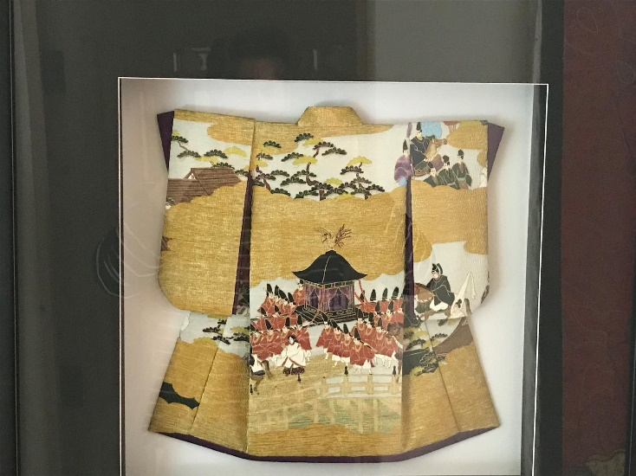
Title: Emperor’s Palanquin
Description/Details: A gold-patterned paper kimono with royal purple lining. The design features popular motif from the Edo period (1600-1869). The scene depicted showcases a Japanese emperor traveling in a palanquin while escorted by his guard and followed by members/ministers of the court.
Previous Description: These exquisite and unique kimonos are made using Kozo (Mulberry paper) featuring popular designs from the Edo period (1600-1868).
Artist/Creator: Karen O’Hanlon
Date: 2010
Medium: Kozo (Mulberry) paper
Country of Origin: Created in Gold Canyon, Arizona

Cultural Background:
Favored by Japanese girls since the early 1500’s, the art of washi ningyo (Japanese Paper Dolls) originated from anesama ningyo, which are flat paper doll. These dolls were made with special Japanese paper and cotton. It can take up two to three hours to make a simple piece for these intricate dolls. The paper kimonos are designed by the students and teachers and inspired by Japanese traditions and cultures. Some of these influences include ukiyo-e (wood block prints), the theater arts in Noh, Kabuki, and Bunraku.

Technique and Materials:
This exquisite and unique creations feature popular designs from the Edo period (1600-1868). Though their appearance closely resembles fabric, these kimonos are made from beautifully patterned paper created by Japanese master craft artisans. Paper kimonos are commonly made with washi papers such as Yuzen or Kozo. Washi papers are handmade from the inner bark of Mulberry, Mitsumata and Gampi trees. O’Hanlon uses two types of Kozo paper: Chiyogami and Yuzen. Chiyogami paper is brightly colored with woodblock-printed patterns. Yuzen paper’s patterns are based from traditional silkscreen designs, closely imitating the silks of Japanese kimonos. See attached documents for a more detailed information.
Paper kimonos are made following the same process of an authentic cloth kimono. To create the paper kimonos, the artist first creates various sized templates for each pattern piece of the kimono. Each kimono consists of layering eleven templates of patterned paper. The artist has to cut, fold, glue, and layer the pattern paper precisely. Working with the fragile paper requires delicate handling. For lining the kimono, the same steps are repeated.
Previous Info: Each kimono presents the appearance of fabric but is actually a beautifully patterned paper. Master craft artisans in Japan use both traditional and modern techniques to make high-quality papers. Karen uses two types of Kozo. One is Chiyogami which is decorated with brightly colored, woodblock-printed patterns. The other is Yuzen which are patterns based on traditional silkscreen designs derived from the silks of the Japanese kimono Karen crafts these works of art by first making templates of varying sizes for each pattern piece of the kimono. Each kimono is made by laying eleven templates on the patterned paper. Karen then cuts, folds, glues, and layers the pattern paper with precision. Due to the delicacy of the patterned paper, the same steps are repeated for the lining of the kimono. The kimono is made exactingly as an authentic cloth kimono.

Artist Background:
(American, 1949-Present)
Karen O'Hanlon designs Chiyogami and Washi (Japanese Paper) Kimonos imitating the same detailed fashion of full sized traditional robes. Each of her works is unique. Her kimonos have the appearance of fabric but are actually made out of paper. The high quality papers she uses are made by Japanese master craft artisans using traditional as well as modern tools and techniques. As a regular visitor to Japan, she studied traditional Japanese arts with Yuriko Kodama. Under Kodama-sensei, O’Hanlon specialized in washi ningyo (paper dolls) focusing on the kimonos. After five years, O’Hanlon mastered the creation of paper kimonos. O’Hanlon’s kimonos are part of various private collection and corporate collections such as Takeda Pharmaceuticals North America, Inc., and Maritz for Yamaha Corporation.

Website: kpohanlonstudio.com / kpokimonoart.com
Email: irishcharms@msn.com (?)
Phone: 480-982-6483
Social Media: https://www.linkedin.com/in/karen-o-hanlon-95236814/?trk=prof-samename-picture

