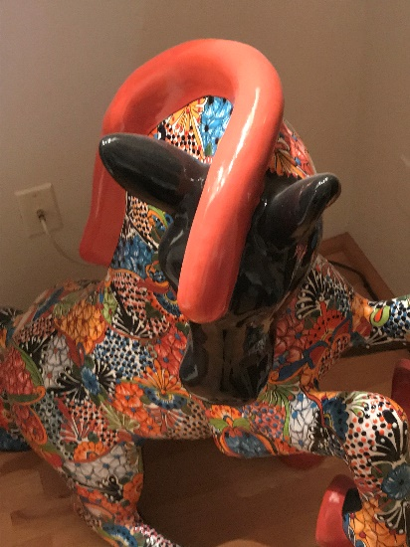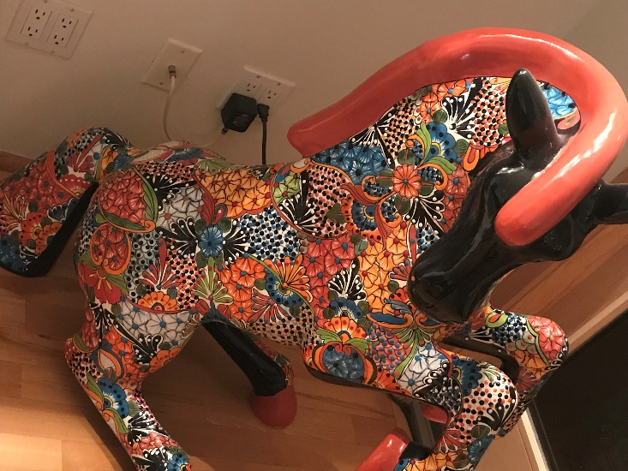

Title: Talavera Horse
Description/Details: Colorful multi-patterned ceramic horse created in the Talavera pottery style which blends indigenous and European artistry. Talavera pottery was introduced in Puebla, Mexico by immigrants from Talavera de la Reina, Spain and has remained a Mexican tradition for centuries. See below for more information on the Talavera style.
Creator: IR (initials on back)
Date: unknown
Medium: majolica earthenware, tin-glazed ceramic with natural pigments
Place of Origin: possibly Puebla, Mexico or Guanajuato, Mexico

Talavera style details: Talavera has been produced by Mexican craftsmen since 16th century as it was introduced during the Spanish colonization of Mexico. Talavera is recognized for its bold colors and detailed patterns with traditional and contemporary Mexican designs. This art form has evolved from ancient cultures and influenced the production of pottery in Mexico.

Talavera style belongs to a larger category of Majolica ceramics, handmade and hand painted earthenware. It is fired at extremely high temperatures producing a very durable product. Artisans are not limited to the production of tiles and vases and by the early 1900s they started creating create plates, jars, pots, religious figures, animals and more. Talavera is distinguished from other majolica styles by its use of natural clays, strong colorful motifs applied to a white background. Some characteristics of genuine Talavera pottery include:
- Talavera is made from a mixture of only two clays, a dark clay and a light, slightly rose-colored clay.
- The source of clay supply to make the Talavera comes from the Talavera geographic zone of Puebla and the communities of Atlixco, Cholula and Tecali.
- Talavera is hand formed with a potter’s wheel or using molds, not poured. They are also hand-painted.
- Talavera pieces have gone through two firings. The oven used to fire Talavera should be at least 800 degrees Celsius.
- Talavera uses six color pigments, and its color combination enhances the workmanship sophistication of Talavera pieces.

Today, true, certified Talavera pottery is produced in the city of Puebla, in the state of Puebla, Mexico. However, high-quality, modern Talavera pottery is also available from factories in other Mexican districts such as Dolores Hidalgo and Guanajuato. The age-old techniques have been passed down from generation to generation by master craftsmen. There were ordinances set for all potters wanting to create in the Talavera style to ensure uniformity and the continuance of the distinctive style and excellence. Some of the ordinances in place includes:
- Blue was to be used on the finest ceramics as the mineral pigments needed to produce this color were very expensive. During the 18th Century the Talavera artisans started to broaden the designs of their ceramic by using more colors, like green, mauve and yellow, in addition to the blue tones that were very popular in the 16th and 17th Centuries.
- To avoid the production of fake Talavera, each master potter was required to sign or mark his products with their specific and registered mark. Certified Talavera pieces bear the signature of the potter, the logo of the workshop, and a special governmental hologram that certifies the piece’s authenticity. Only pieces from government approved workshops that meet the standards are certified and considered authentic Talavera. *see below for today’s standards for certification*
- Three types of earthenware were to be produced depending on the quality of the pieces: Fine, Semi fine, and for Daily use
Some of these ordinances are still followed by today Talavera artisans. The Talavera produced in certain workshops in Puebla is now officially designated, recognized and protected by the Government of Mexico. These Talavera manufacturers must follow a complex and strict technical fabrication process dating from the 16th Century and use only clay from a few approved clay sites in the Puebla area.
Today, authentic Talavera pottery production is regulated by the Talavera Regulatory Council (CRT). Workshops looking to produce authentic Talavera must apply for certification from the council and pass a monthly verification process. Certification usually takes a year and requires artists to learn the appropriate kiln temperature (900 C), how to use the allowed colors (blue, yellow, black, green, orange, and mauve), and other important Talavera characteristics. Furthermore, aside from certification a workshop must meet the requirements set by the Official Mexican Standard (NOM). Some of the standards set by NOM include that workshops are only allowed to use two types of clay, the clay must be hand-formed by the artist, and pieces must be painted by hand.
Once a workshop is certified, potters receive special holographic sticker to guarantee their products are authentic Talavera. Stickers are placed next to the logo of a workshop and signature of the potter, as seen in the image below. Additionally, each workshop/artist keeps an inventory or catalogs the Talavera produced and sold. The majority of purchases are accompanied with a certificate of authenticity from the workshop/gallery.

As of 2020, the CRT represents nine Talavera certified producers: Uriarte Talavera, Talavera La Reyna, Talavera Armando, Talavera Celia, Talavera Santa Catarina, Talavera de la Nueva España, Talavera de la Luz, Talavera de las Americas, and Talavera Virglio Perez. Each workshop is made up of various potter whose style is distinguished by the detail in decoration, use of colors, and shapes adopted by the workshop they belong to. The oldest workshop, Uriarte Talavera, was founded in 1824 by Dimas Uriarte, and continues to produce their characteristic traditional colonial-era designs.

Logos of Talavera workshops
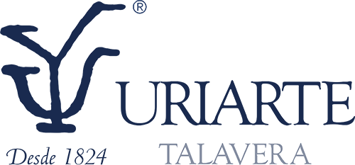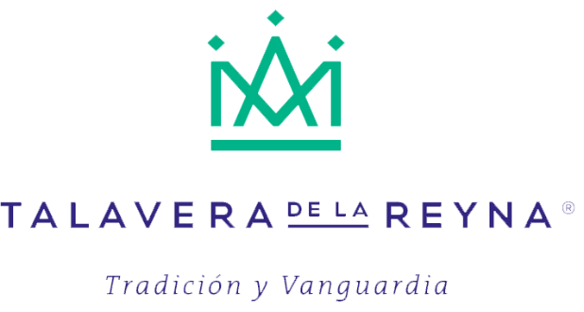
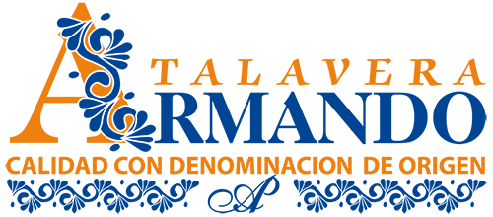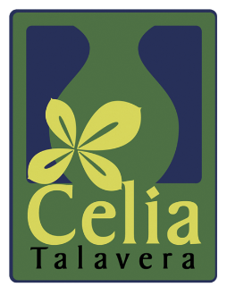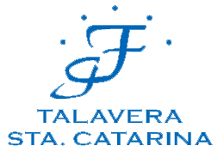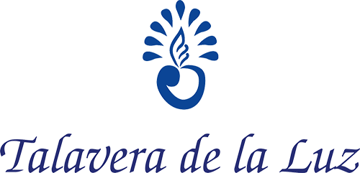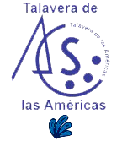

Information taken from http://www.talavera.com/
https://mexiconewsdaily.com/news/pottery-makers-certification-sought-to-combat-fake-talavera/
Members of the CRT: http://www.consejoreguladordetalavera.com.mx/miembros-consejo.html

